2008

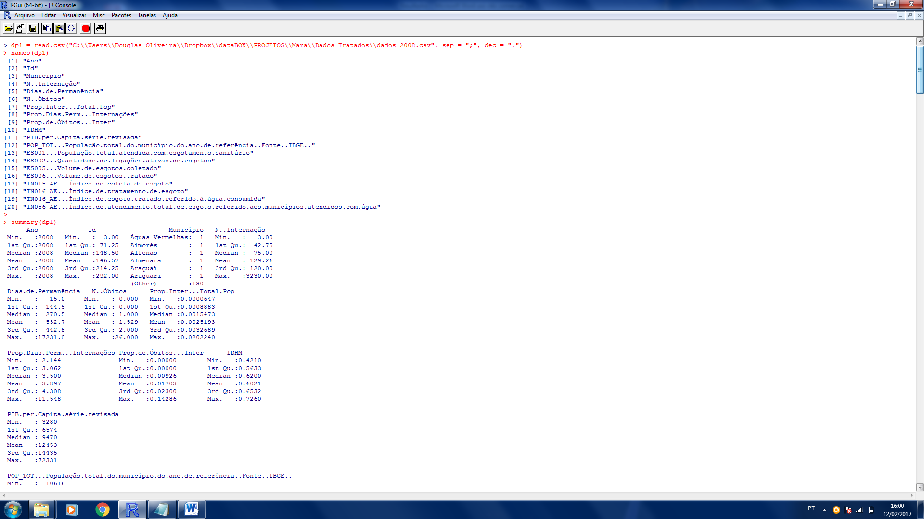

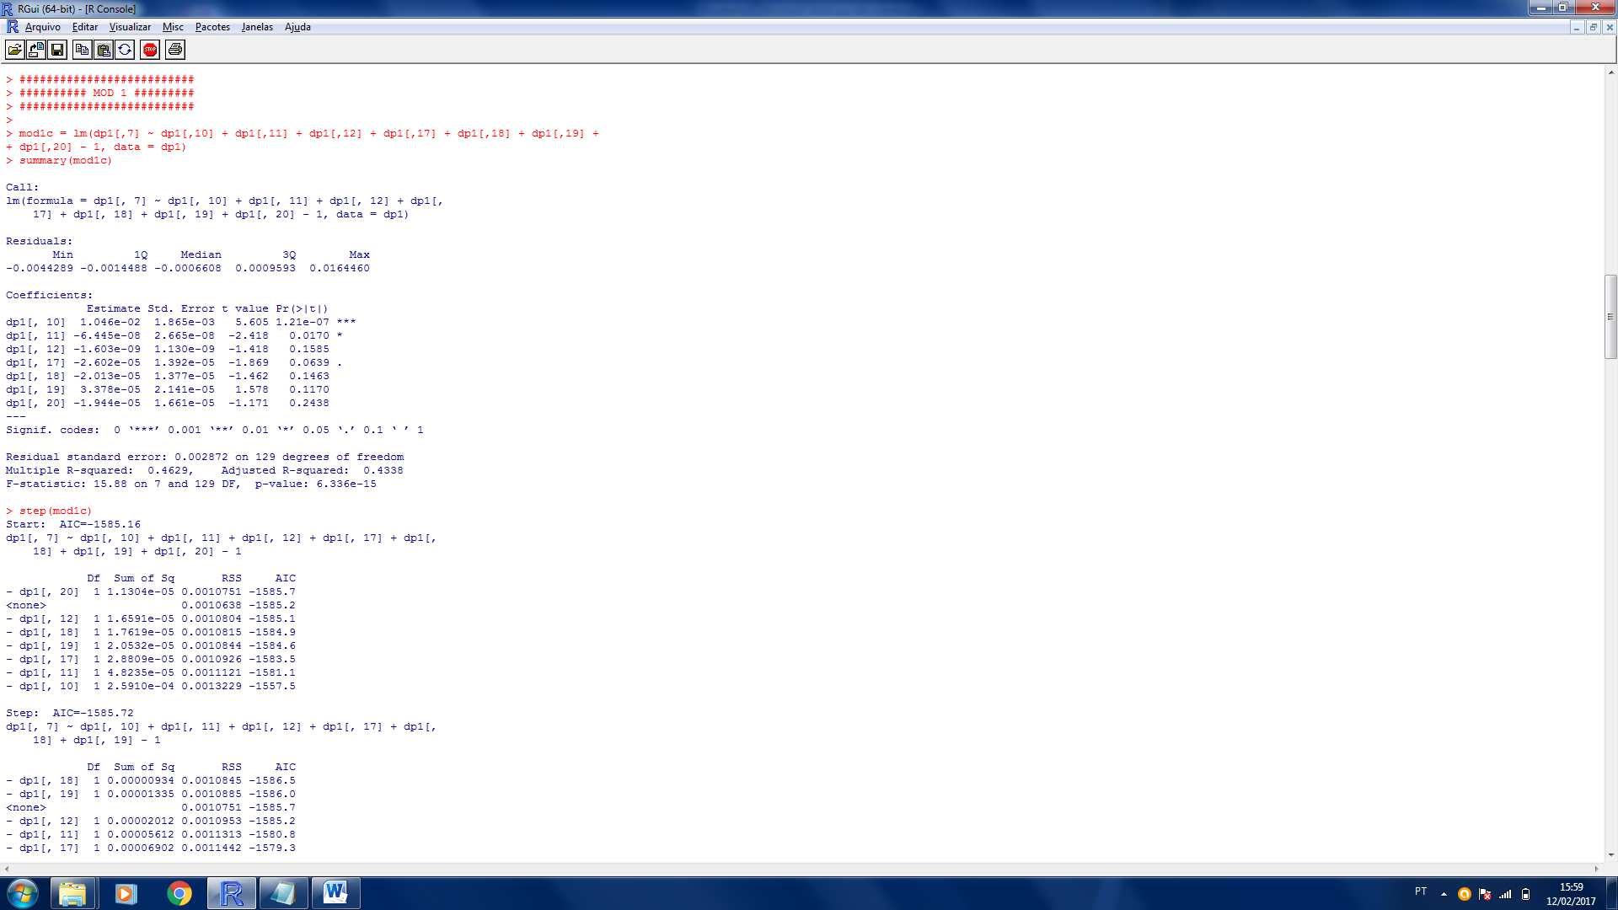



….

(método *Stepwise*)

É possível verificar que o conjunto de variáveis explica 0,45% da variância de Y(Proporção de Internados). Além disso, pelo Teste ANOVA é possível verificar que o modelo apresenta significância estatística.

Residual standard error: 0.002872

Multiple R-squared: 0.4505

Adjusted R-squared: 0.4338

F-statistic: 27.05 on 4 and 132 DF

p-value: < 2.2e-16

ANOVA :

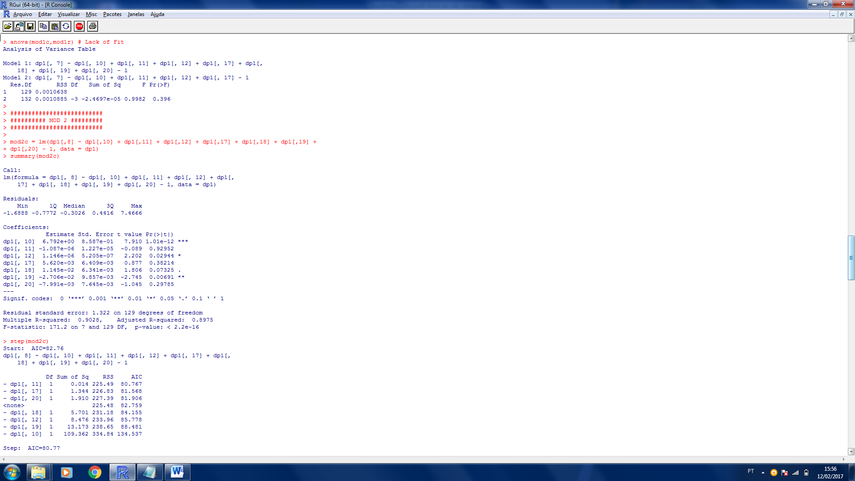

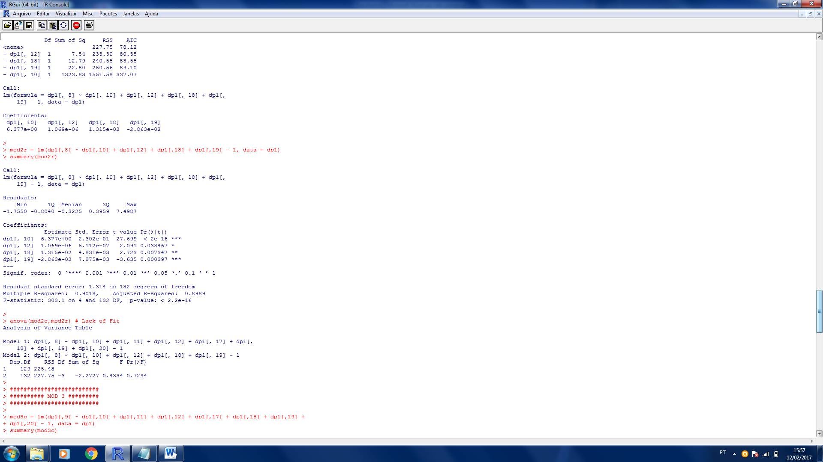

Residual standard error: 1.314

Multiple R-squared: 0.9018

Adjusted R-squared: 0.8989

F-statistic: 302.1 on 4 and 132 DF

p-value: < 2.2e-16

ANOVA :

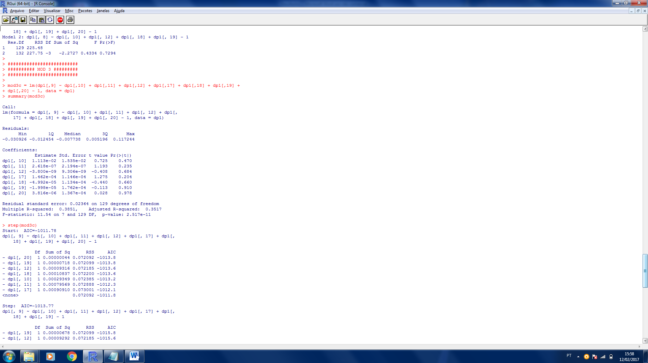

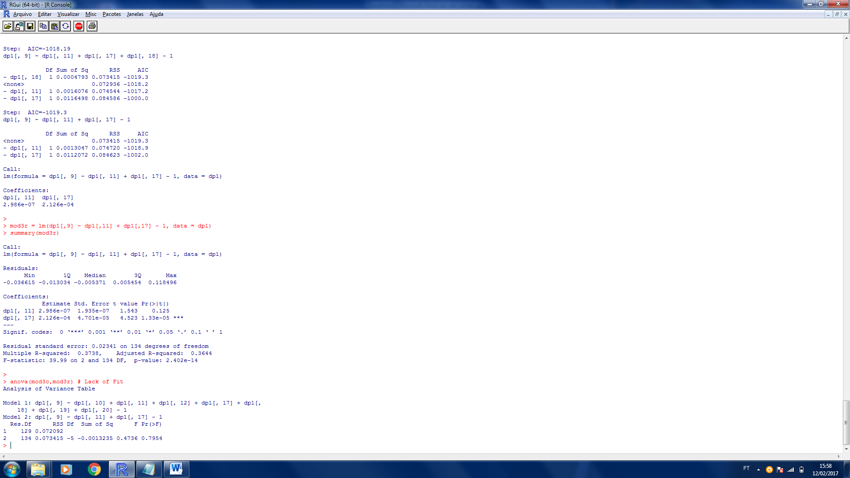

Residual standard error: 0.02341

Multiple R-squared: 0.3738

Adjusted R-squared: 0.3644

F-statistic: 39.99 on 2 and 134 DF

p-value: < 2.406e-14

ANOVA :

2009

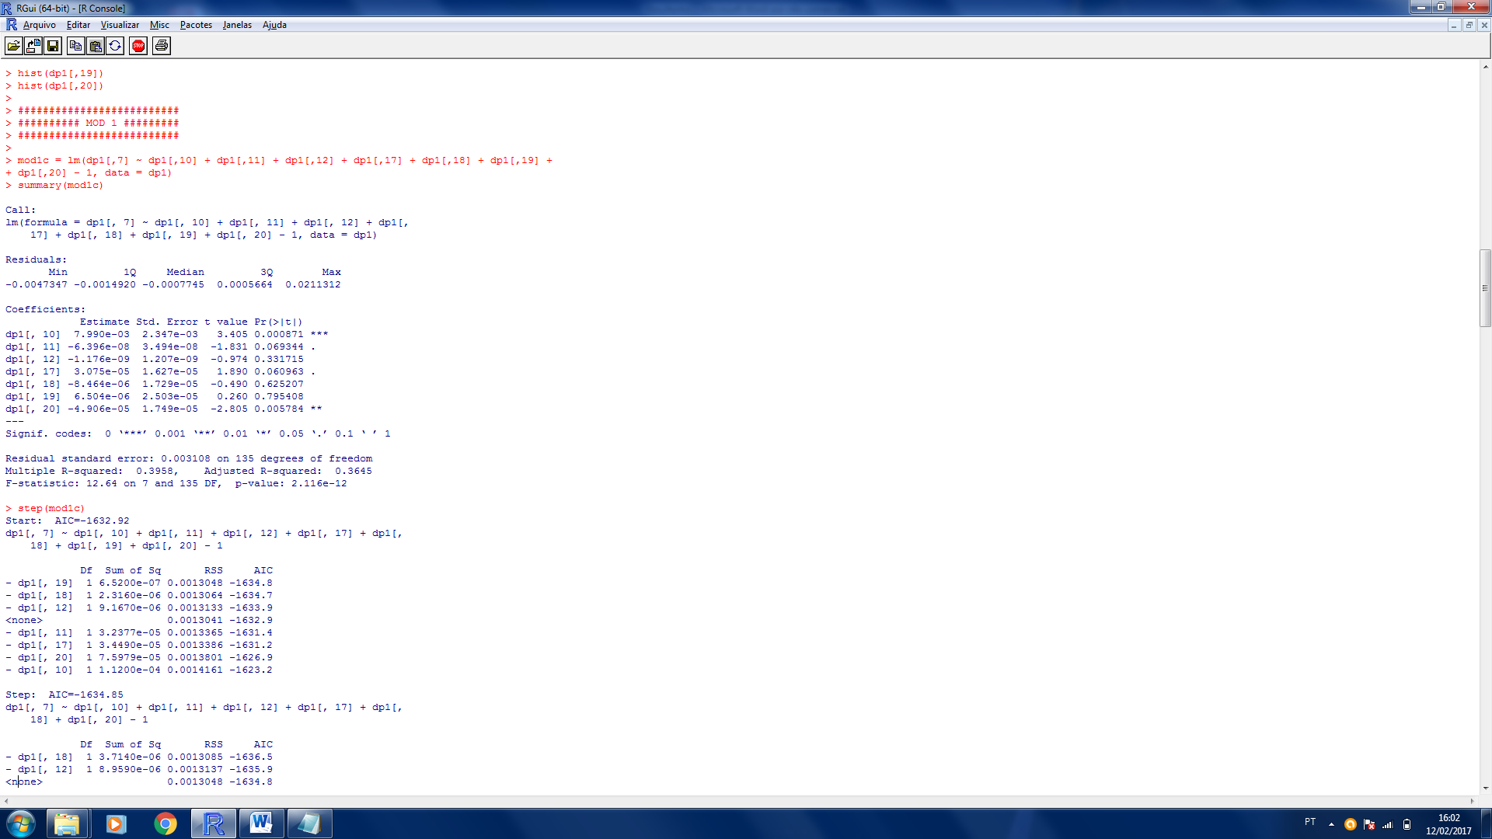

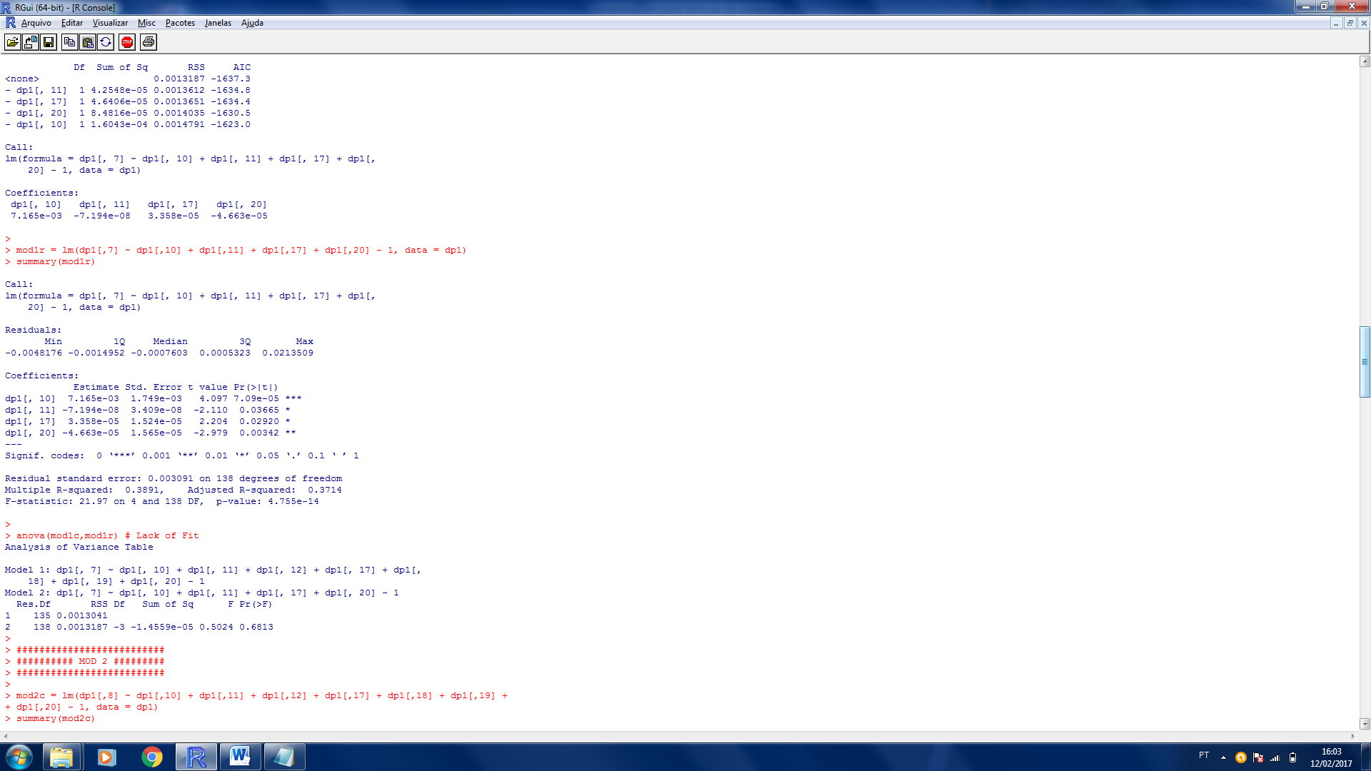

Residual standard error: 0.003091

Multiple R-squared: 0.3891

Adjusted R-squared: 0.3714

F-statistic: 21.97 on 4 and 138 DF

p-value: < 4.755e-14

ANOVA :

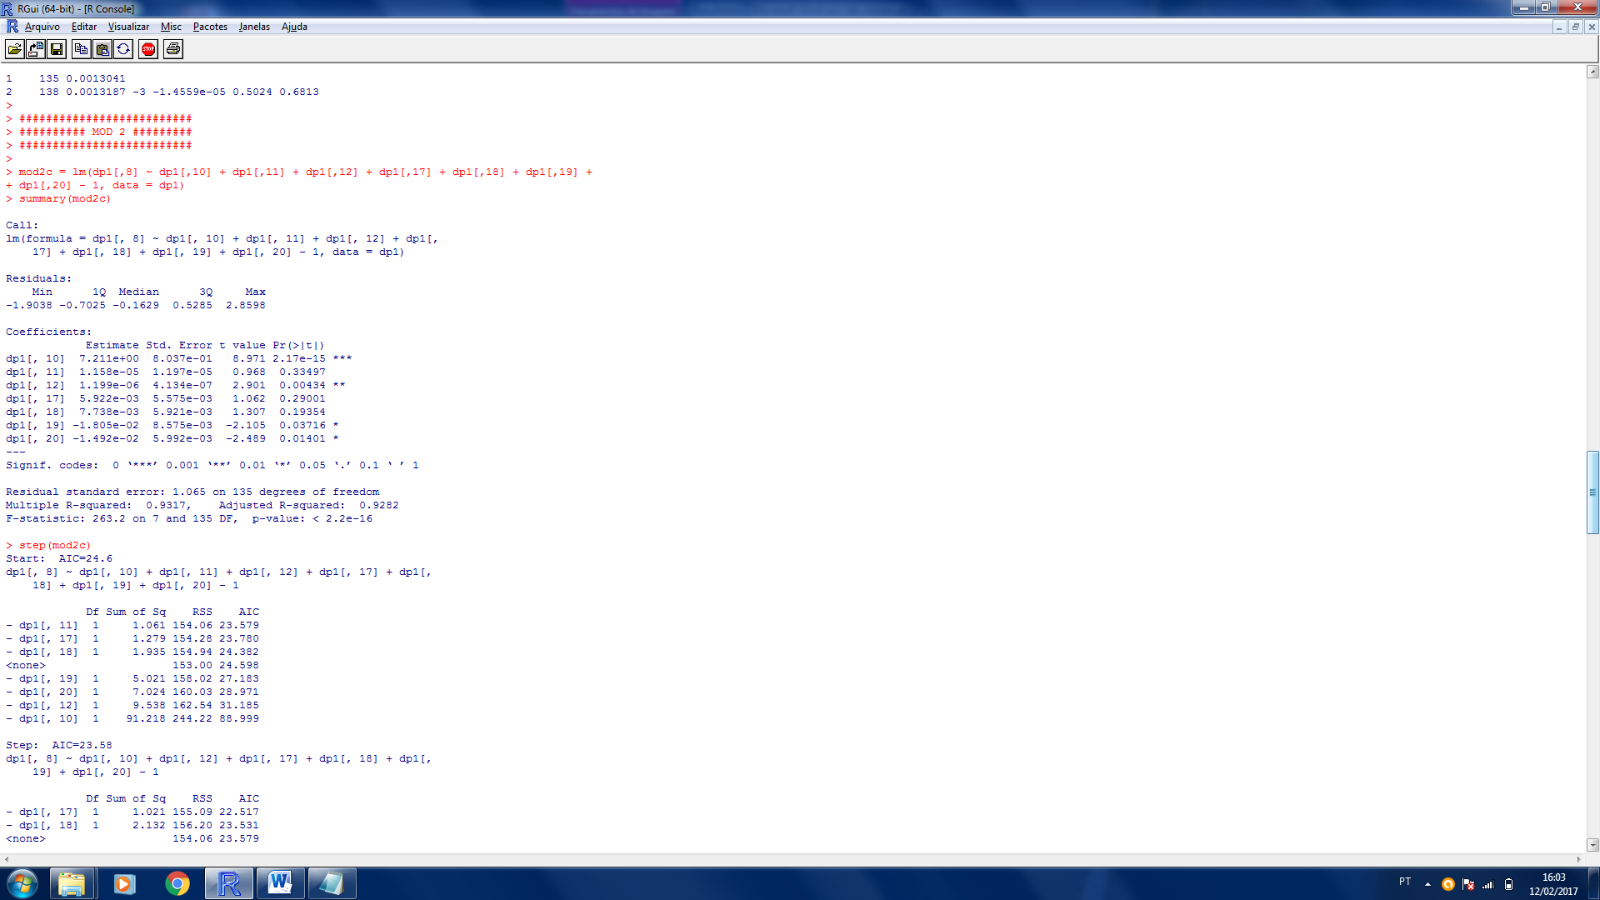

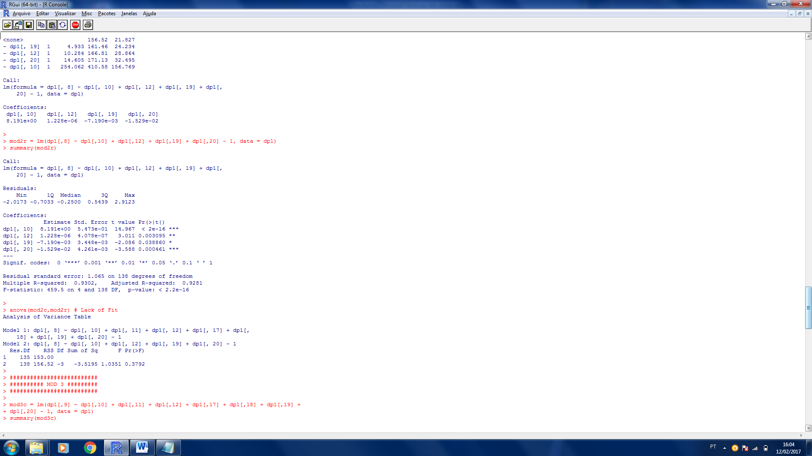

Residual standard error: 1.065

Multiple R-squared: 0.9302

Adjusted R-squared: 0.9281

F-statistic: 459.5 on 4 and 138 DF

p-value: < 2.2e-16

ANOVA :

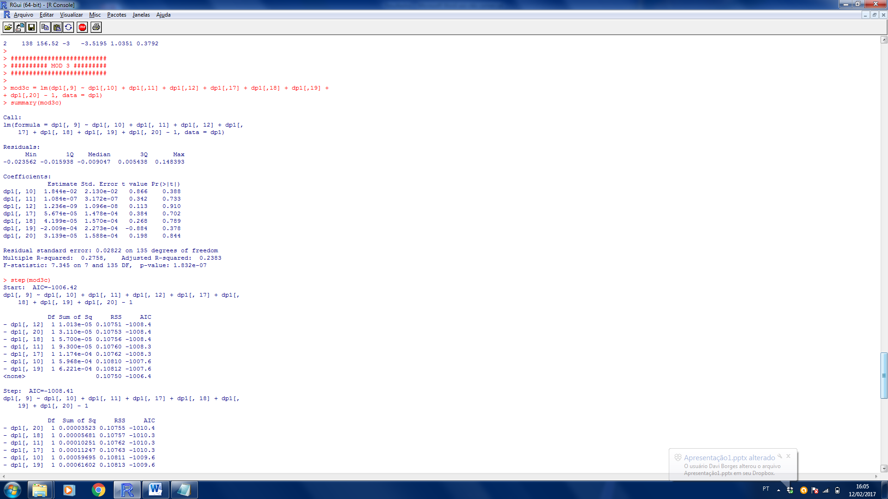

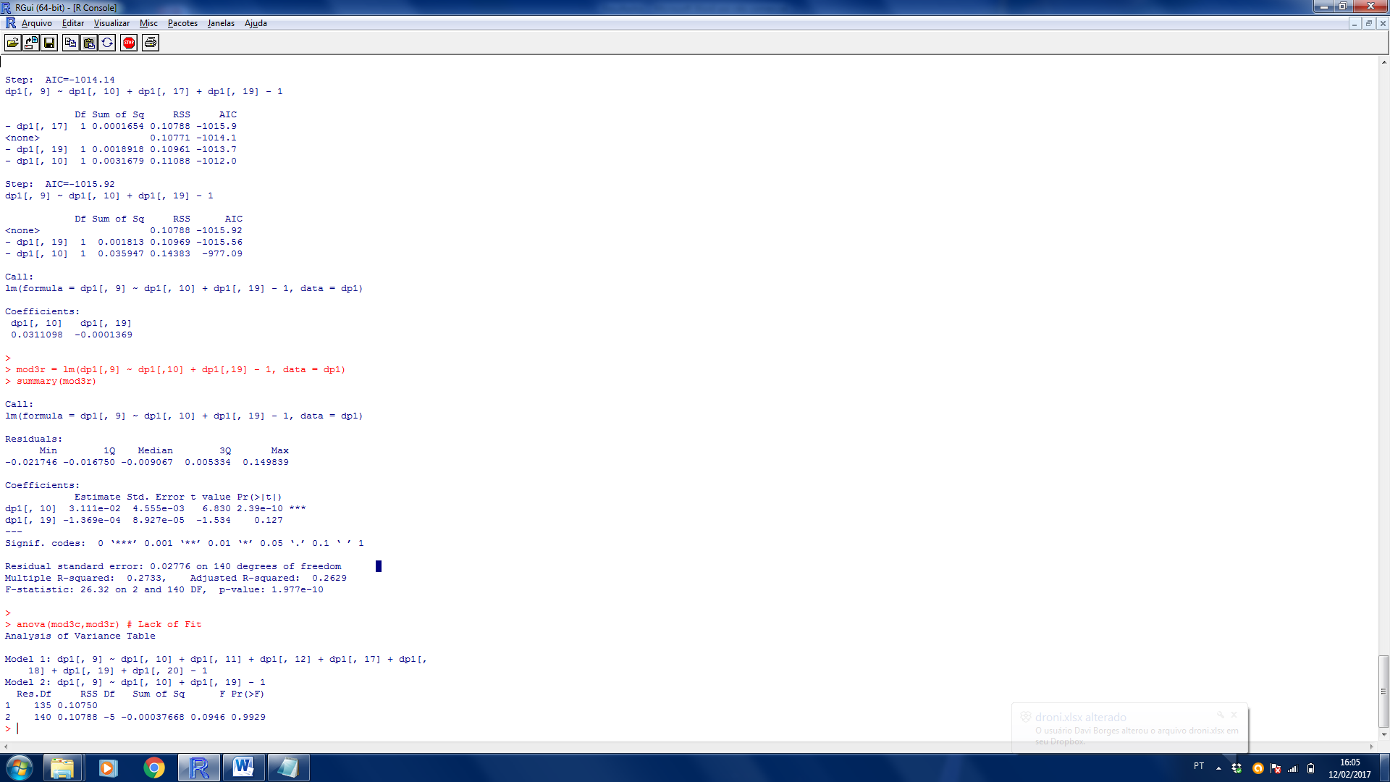

Residual standard error: 0.02776

Multiple R-squared: 0.2733

Adjusted R-squared: 0.2629

F-statistic: 26.32 on 2 and 140 DF

p-value: < 1.977e-10

ANOVA :

2010

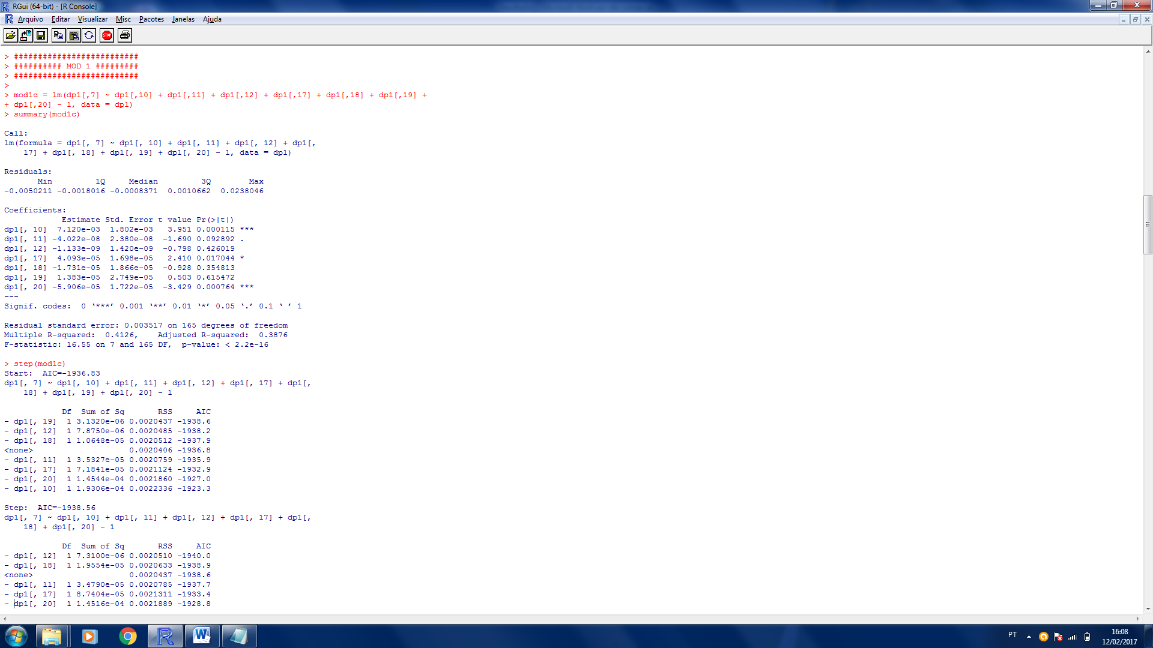

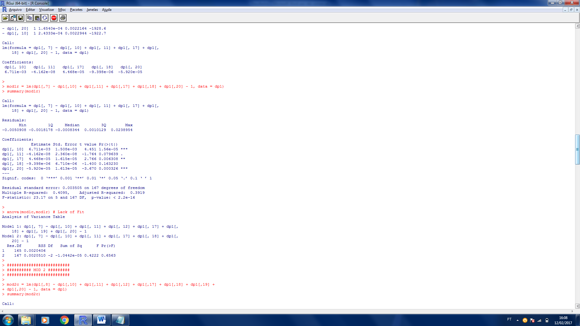

Residual standard error: 0.003505

Multiple R-squared: 0.4095

Adjusted R-squared: 0.3919

F-statistic: 23.17 on 5 and 167 DF

p-value: < 2.2e-16

ANOVA :

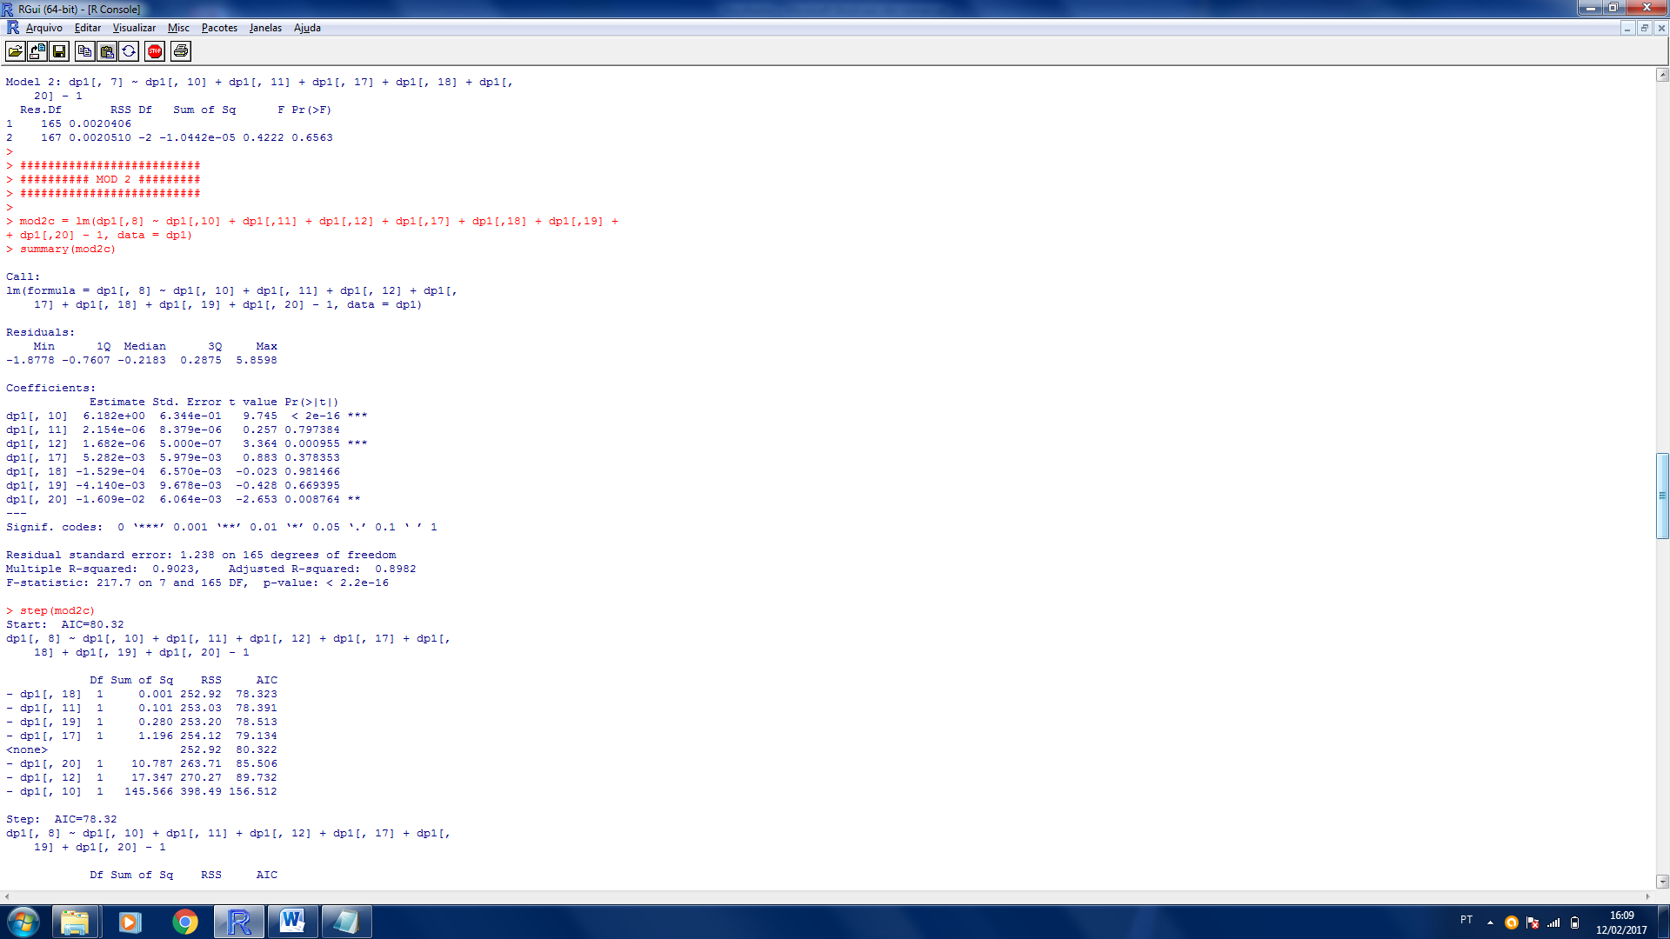

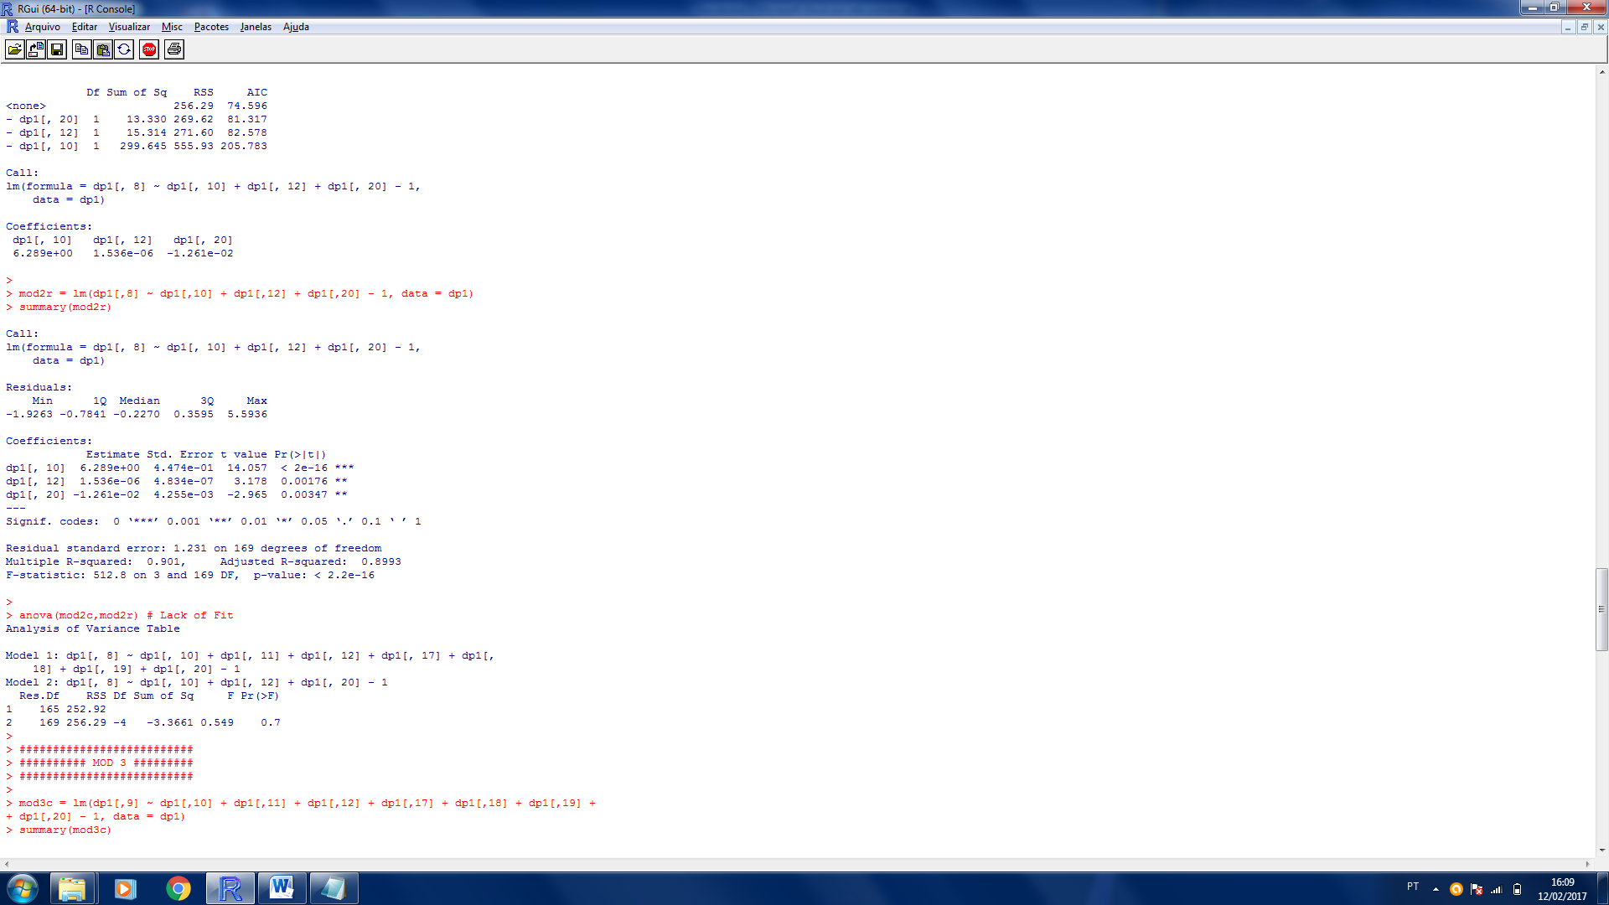

Residual standard error: 1.231

Multiple R-squared: 0.9001

Adjusted R-squared: 0.8993

F-statistic: 23.17 on 5 and 167 DF

p-value: < 2.2e-16

ANOVA :

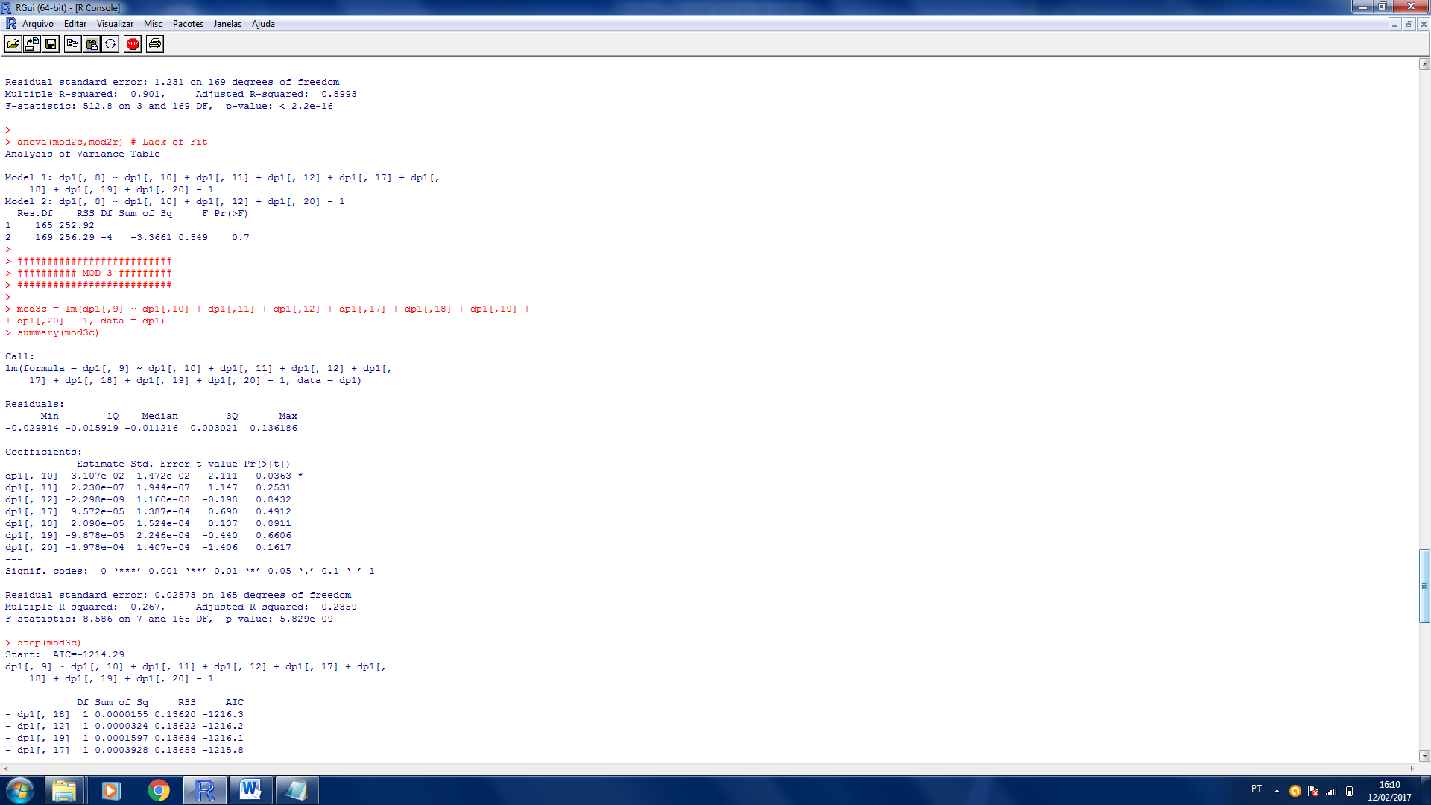

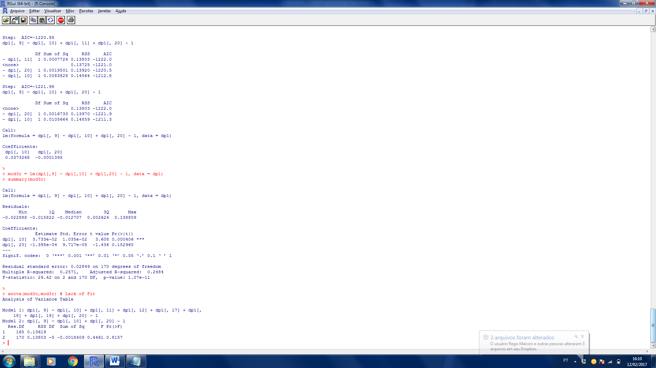

Residual standard error: 0.02849

Multiple R-squared: 0.2571

Adjusted R-squared: 0.2484

F-statistic: 29.42 on 2 and 170 DF

p-value: < 1.07e-11

ANOVA :

2011

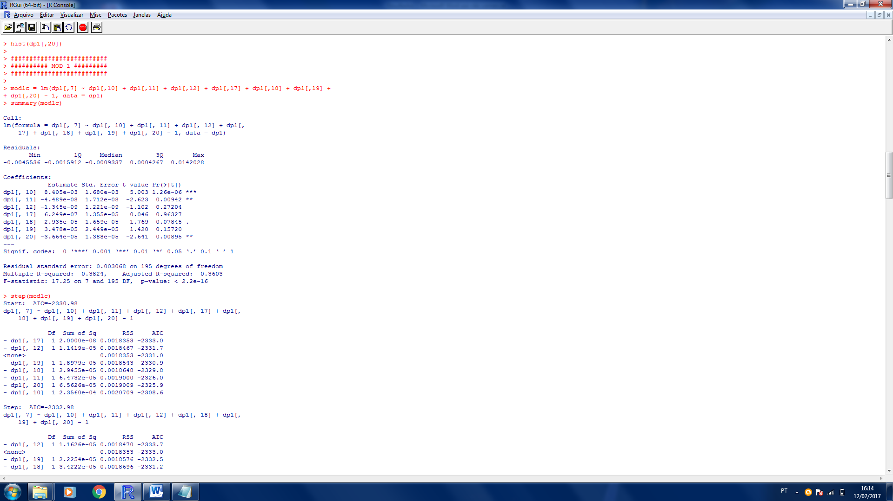

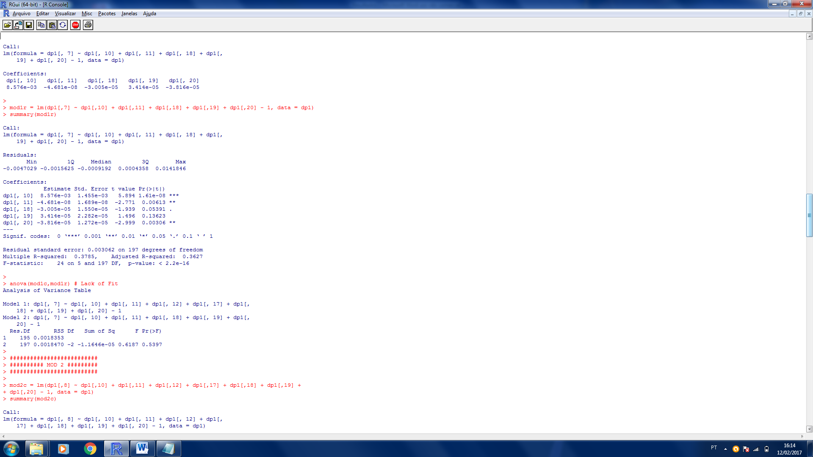

Residual standard error: 0.003062

Multiple R-squared: 0.3785

Adjusted R-squared: 0.3627

F-statistic: 24 on 5 and 197 DF

p-value: < 2.2e-16

ANOVA :

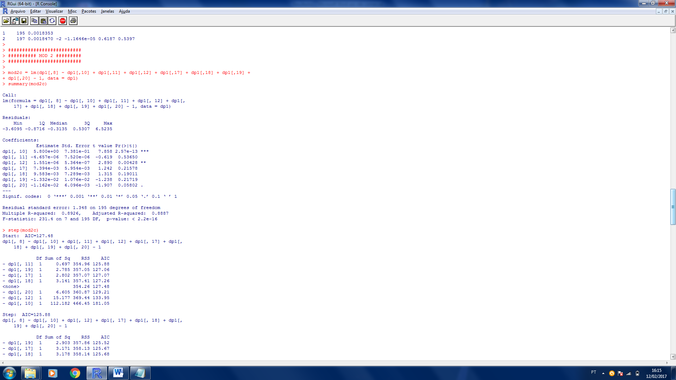

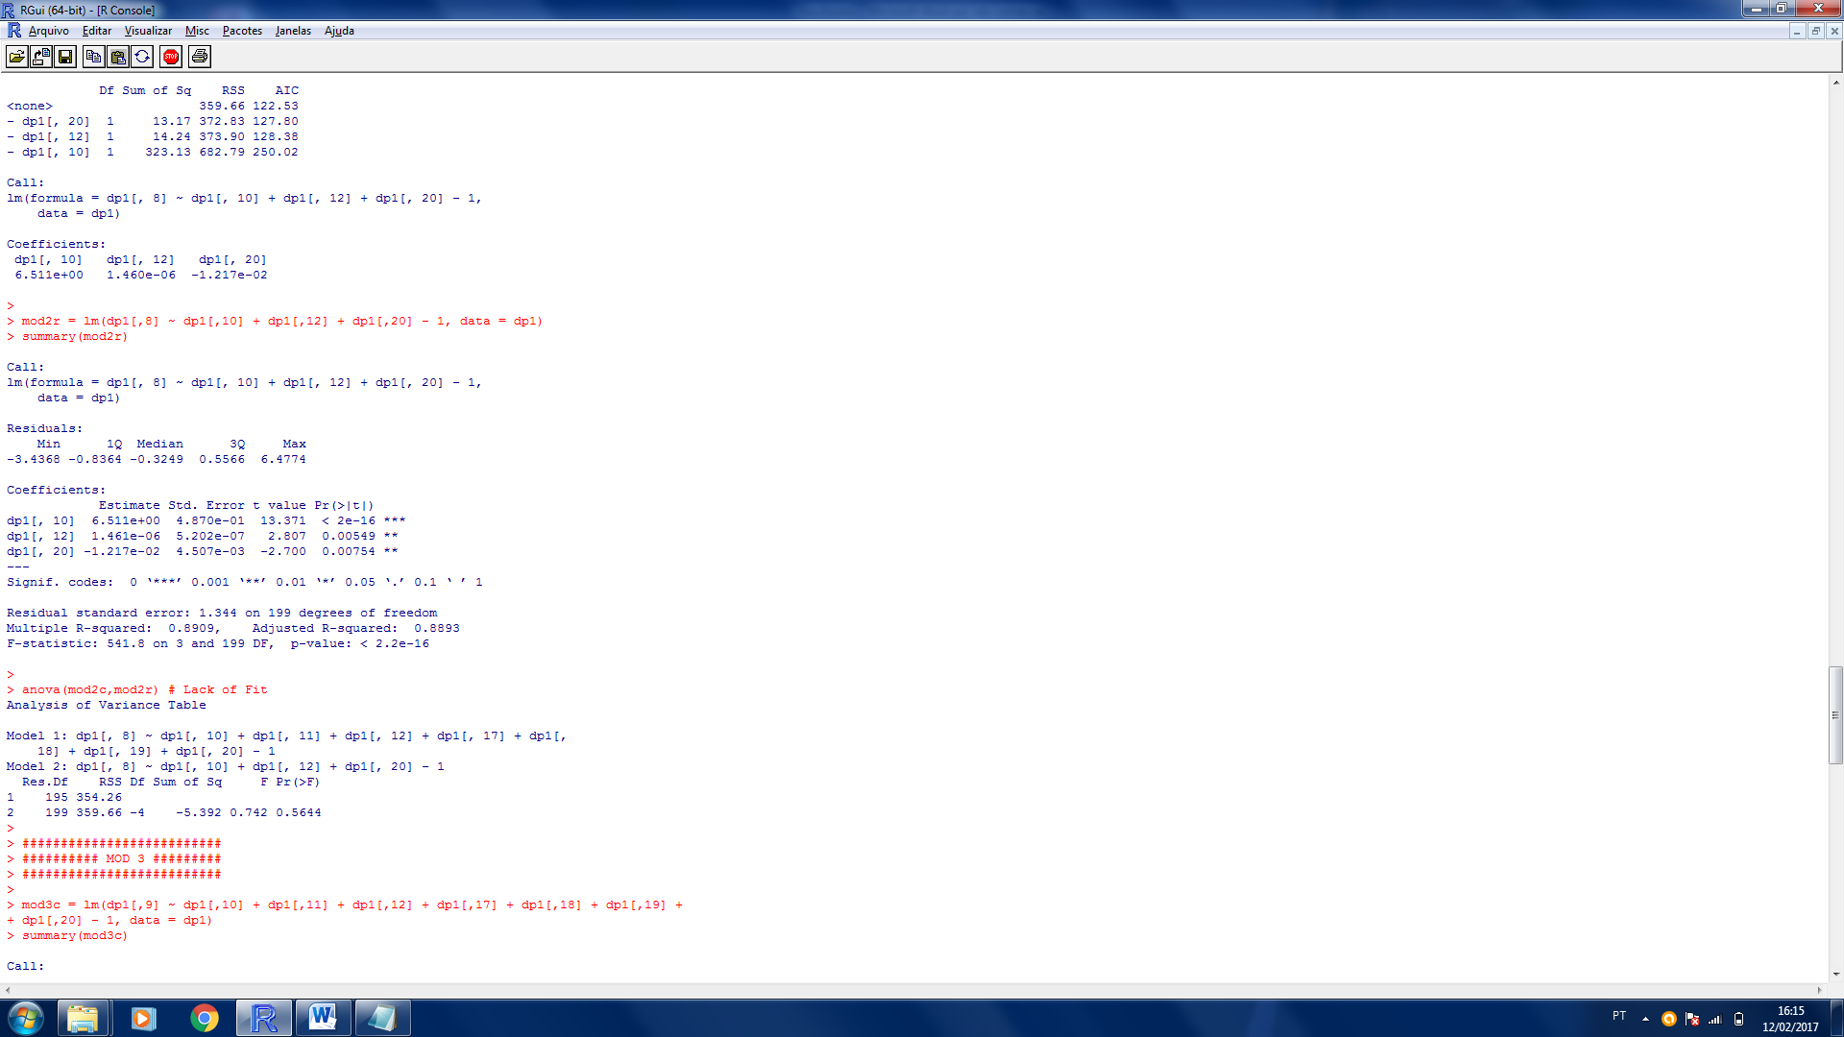

Residual standard error: 1.344

Multiple R-squared: 0.8909

Adjusted R-squared: 0.8893

F-statistic: 541.8 on 3 and 199 DF

p-value: < 2.2e-16

ANOVA :

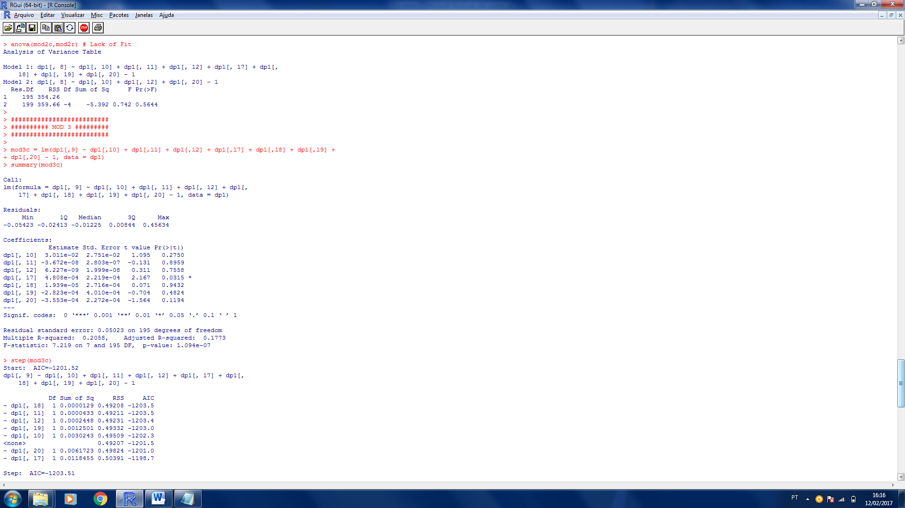

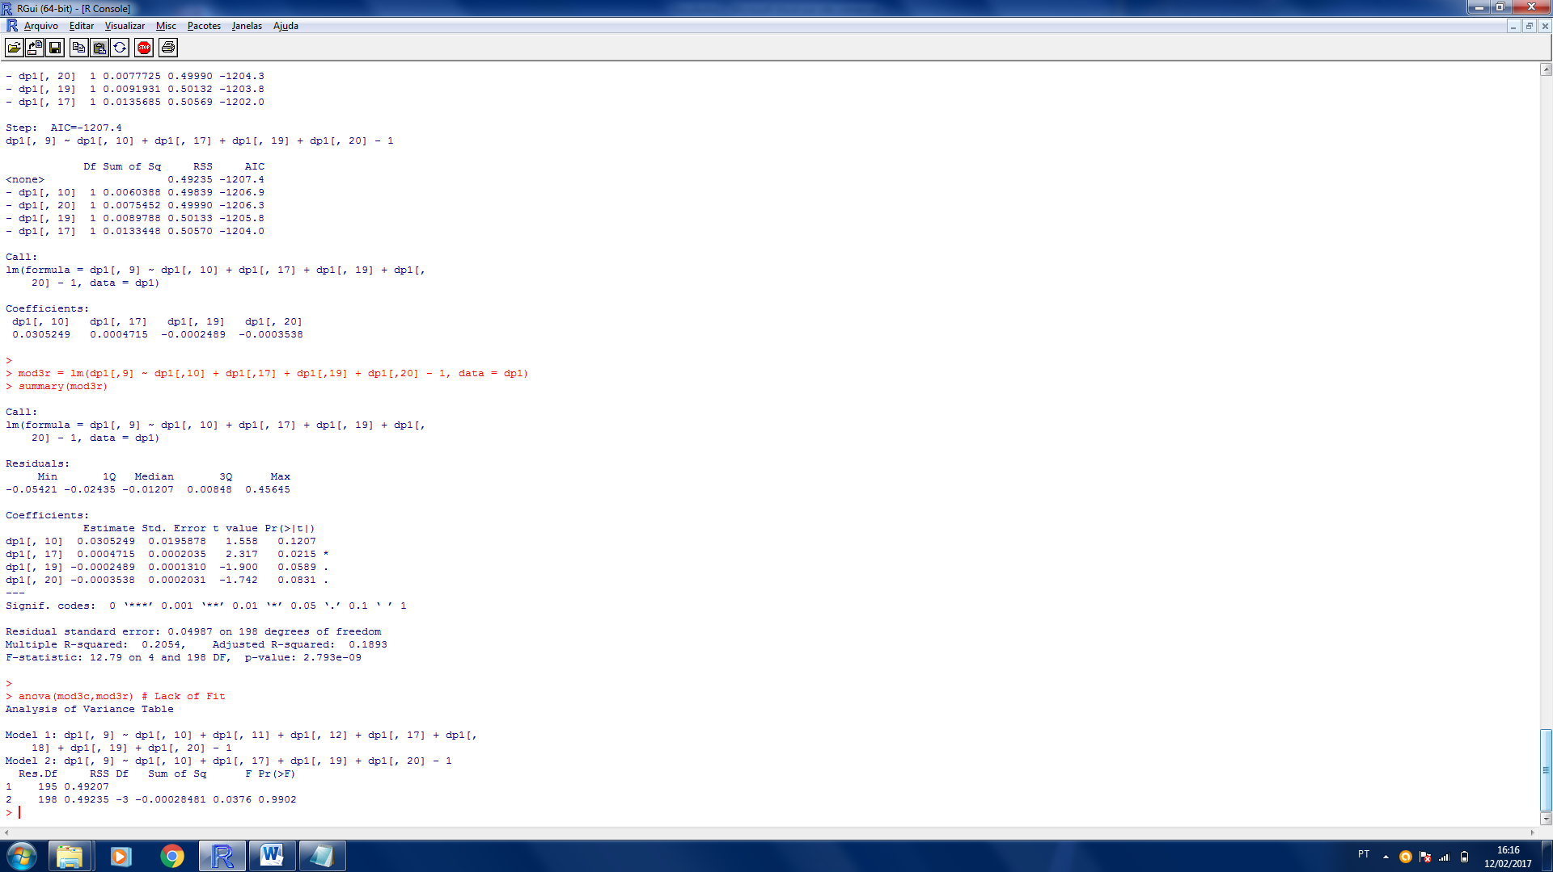

Residual standard error: 0.04987

Multiple R-squared: 0.2054

Adjusted R-squared: 0.1893

F-statistic: 12.79 on 4 and 198 DF

p-value: < 2.793e-16

ANOVA :

2012

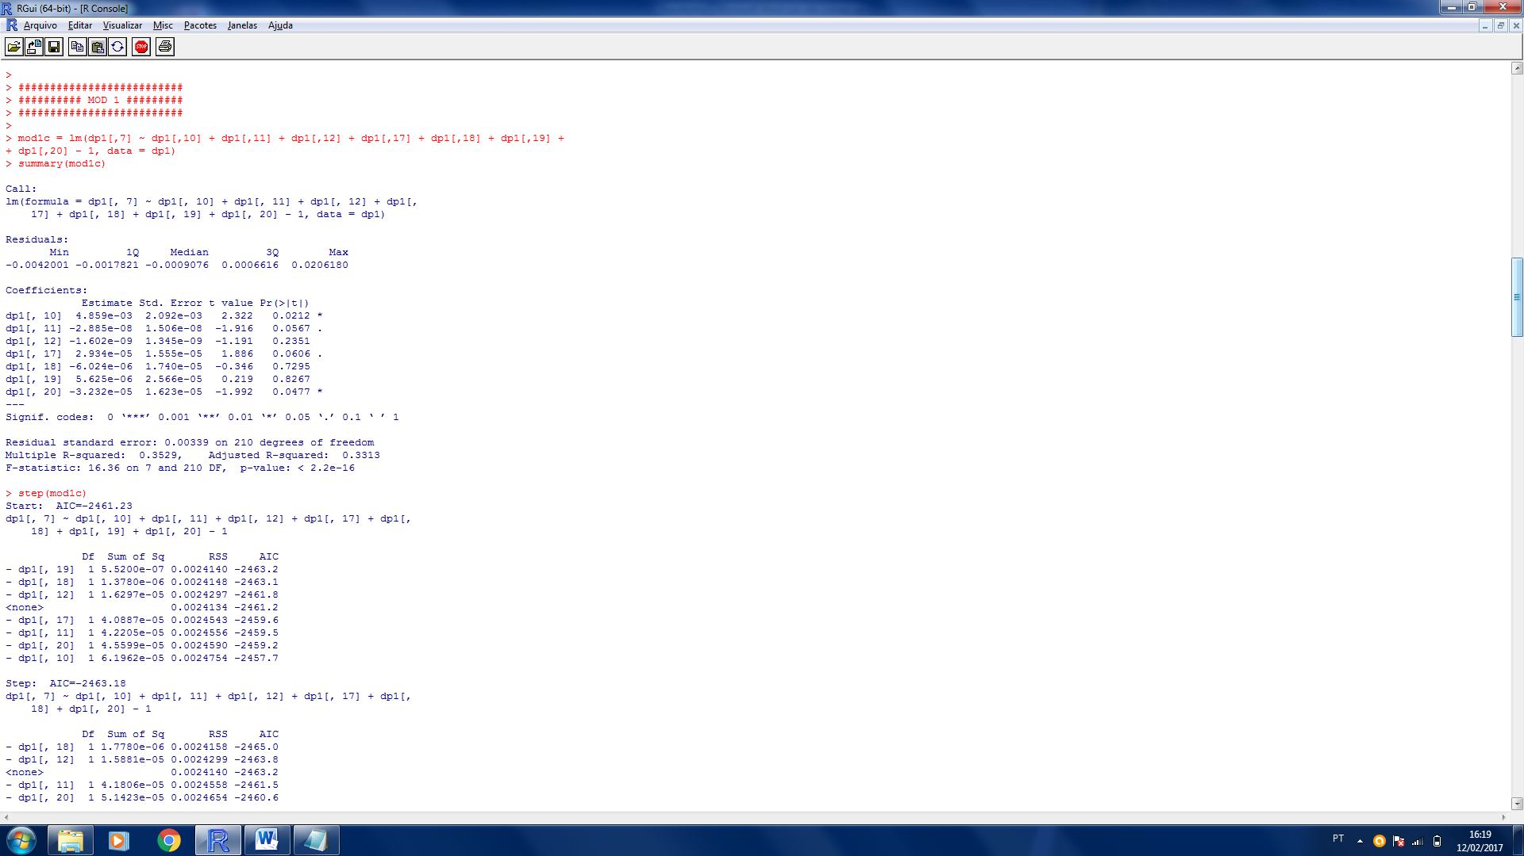

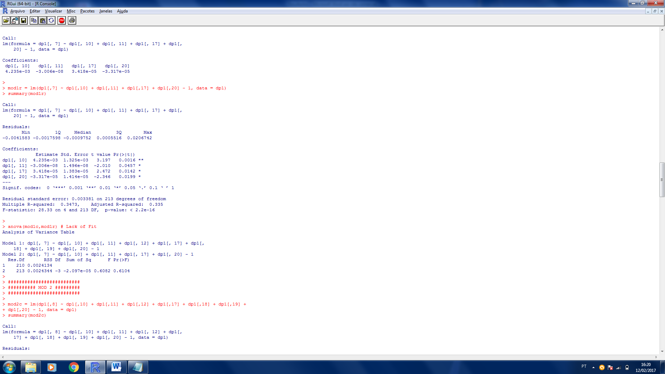

Residual standard error: 0.003381

Multiple R-squared: 0.3473

Adjusted R-squared: 0.335

F-statistic: 28.33 on 4 and 213 DF

p-value: < 2.2e-16

ANOVA :

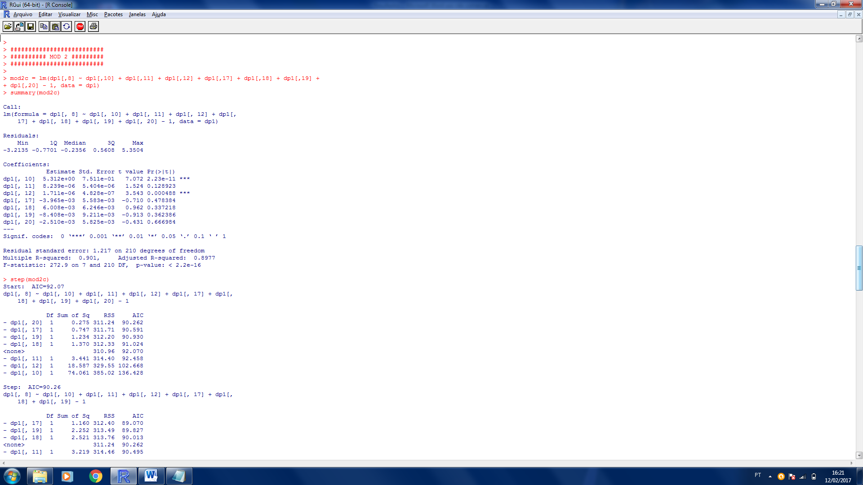

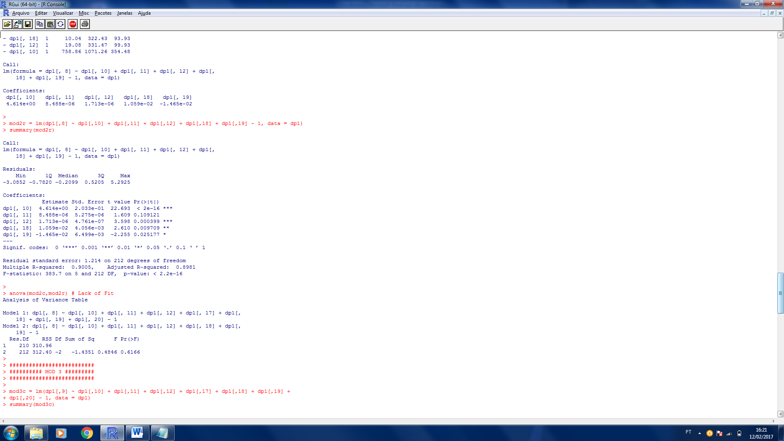

Residual standard error: 1.214

Multiple R-squared: 0.9005

Adjusted R-squared: 0.8981

F-statistic: 383.7 on 5 and 212 DF

p-value: < 2.2e-16

ANOVA :

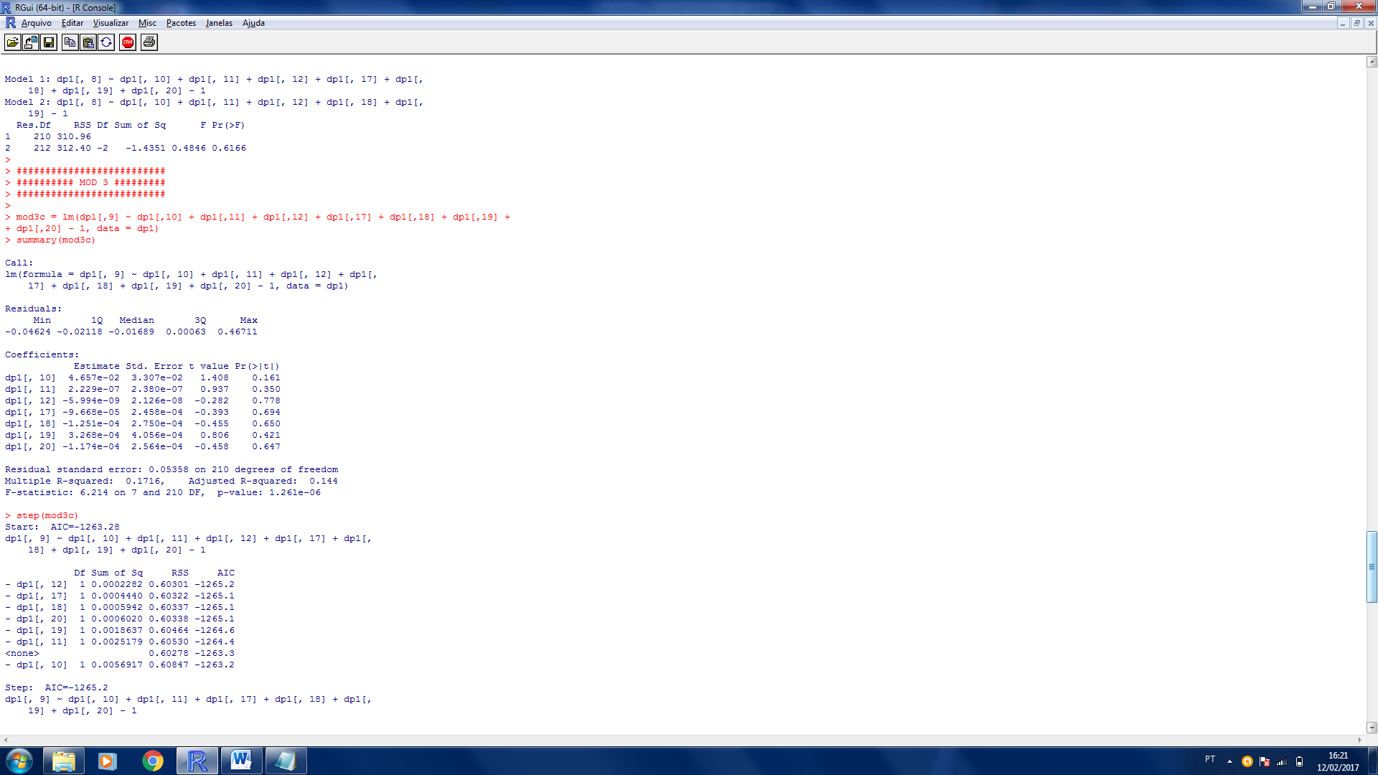



Residual standard error: 0.05316

Multiple R-squared: 0.1611

Adjusted R-squared: 0.1572

F-statistic: 41.47 on 1 and 216 DF

p-value: < 7.653e-10

ANOVA :

2013

2014